
LESSON NOTE | DETAILED EXPLANATORY NOTES
BIOENERGY
SUGAR BATTERIES
GRADE 12 - BIOLOGY
■ ■ ■

What is a Sugar Battery?
A sugar battery is a type of bio-battery that produces electricity from glucose (sugar). It is an enzymatic biofuel cell: enzymes act as catalysts to oxidise glucose at the anode, releasing electrons that flow through a circuit as electric current. In effect, a sugar battery does what a living cell does during respiration - it releases the energy stored in glucose - but it captures that energy as electricity rather than heat.
Sugar is cheap, abundant, renewable and non-toxic, and it stores a lot of energy per gram, so sugar batteries are a promising clean power source. This lesson explains what a sugar battery is, how enzymes oxidise glucose to make electricity, its advantages and uses - including powering medical implants from the body's own blood sugar - and its potential in Papua New Guinea.
Why Sugar Batteries Matter
- Sugar is cheap, renewable and non-toxic - a safe fuel.
- Glucose stores a high amount of energy per gram.
- A sugar battery could power medical implants using the body's own glucose.
- It shows how the chemistry of respiration can be used to make electricity.
Sugar Batteries
Key Learning Outcomes
By the end of this lesson, students should be able to:
- Define a sugar battery and identify it as an enzymatic biofuel cell.
- Explain how enzymes oxidise glucose to release electrons at the anode.
- Describe what happens at the cathode (oxygen reduced to water).
- Link the sugar battery to cellular respiration.
- Discuss the advantages, limitations and uses, including in Papua New Guinea.
How a Sugar Battery Works
A sugar battery has an anode and a cathode, like any battery. At the anode, an enzyme (such as glucose oxidase) oxidises glucose, stripping off electrons (e⁻) and hydrogen ions (H⁺). The electrons travel out through the external circuit - powering a device - and reach the cathode, where they combine with oxygen (O₂) and H⁺ to form water. The H⁺ ions move through the electrolyte to complete the circuit. The overall reaction is the controlled 'burning' of sugar in oxygen, with the energy captured as electricity.
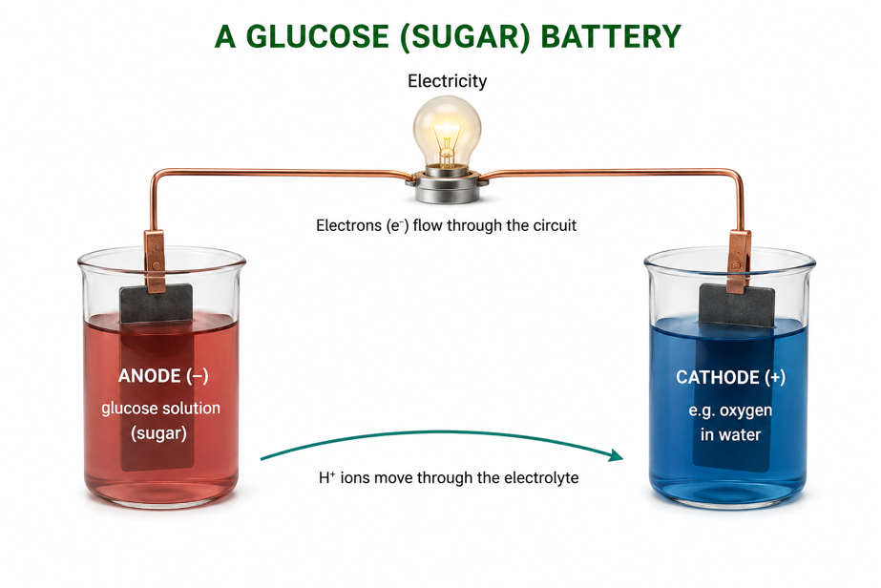
Figure 1: A sugar battery - an enzyme oxidises glucose at the anode; electrons flow through the circuit;
oxygen is reduced to water at the cathode.
Terminologies and Concepts
Useful terms for this topic:
- Sugar battery: a bio-battery that makes electricity from glucose.
- Enzymatic biofuel cell: a cell that uses enzymes to oxidise a biological fuel.
- Glucose: the simple sugar used as the fuel.
- Enzyme (glucose oxidase): the biological catalyst that oxidises glucose.
- Oxidation: loss of electrons (at the anode); Reduction: gain of electrons (at the cathode).
- Electrolyte: the medium that carries H⁺ ions between the electrodes.
- Energy density: the amount of energy stored per gram of fuel.
Oxidising Glucose to Make Electricity
The heart of the sugar battery is the enzyme-catalysed oxidation of glucose at the anode. The enzyme removes electrons from glucose, turning it into gluconolactone and releasing 2 electrons and 2 H⁺. This is exactly the kind of reaction that begins respiration inside our cells - but here the electrons are directed into a wire instead of into the cell's energy-carrying molecules. Because enzymes are very specific and efficient, they can pull energy from glucose gently, at body temperature, without burning.
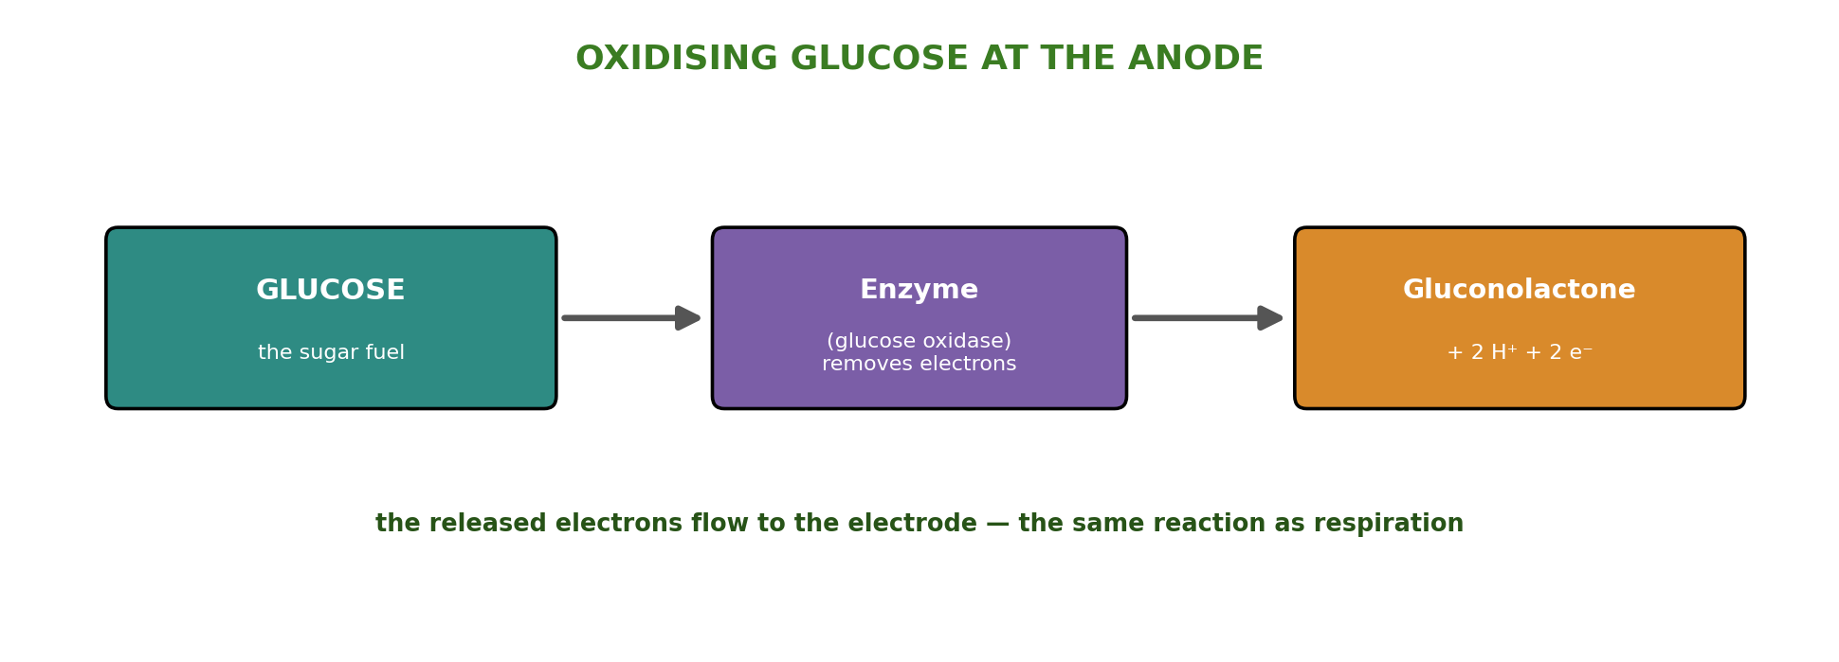
Figure 2: An enzyme oxidises glucose to gluconolactone, releasing electrons that flow to the electrode.
The Link to Respiration
A sugar battery is really respiration turned into a battery. In cells, glucose is oxidised and oxygen is reduced to water, releasing energy that is stored as ATP. In a sugar battery, glucose is oxidised at the anode and oxygen is reduced at the cathode - the same overall reaction - but the energy is captured as electric current. Understanding respiration therefore helps explain how a sugar battery works, and why glucose is such a good fuel: living things have used it to store energy for billions of years.
Uses of Sugar Batteries
Because glucose is safe and available everywhere, sugar batteries have several promising uses:
- Medical implants - powering pacemakers and sensors using the glucose already in the blood.
- Portable electronics - a renewable, non-toxic power source for small devices.
- High-energy storage - sugar's high energy density means a lot of energy in a small mass.
- Remote / low-cost power - running small sensors where sugar or plant sap is available.
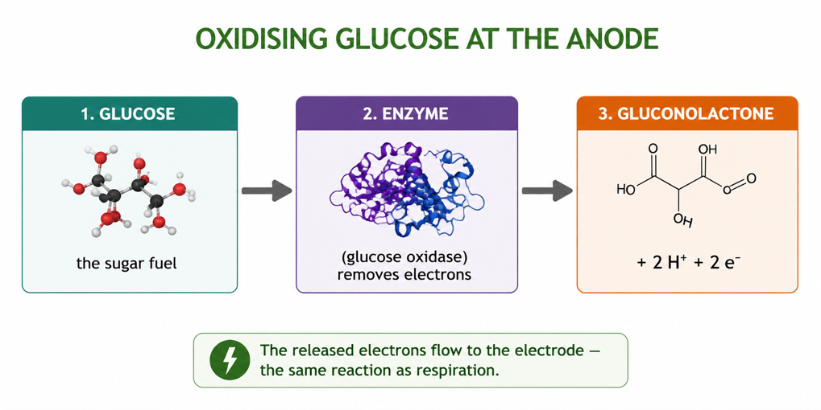
Figure 3: Uses of sugar batteries - from powering implants on blood glucose to portable, renewable power.
Advantages and Disadvantages
Advantages | Disadvantages
Fuel (sugar) is cheap, renewable and non-toxic | Produces only small amounts of power
High energy stored per gram of glucose | Enzymes wear out and must be replaced
Can run on the body's own blood glucose | Sensitive to temperature and pH
Works gently at body temperature | Still mostly a developing technology
Worked Example The Overall Reaction
A sugar battery carries out the same overall reaction as respiration:
C₆H₁₂O₆ + 6 O₂ → 6 CO₂ + 6 H₂O + energy
The glucose is oxidised (losing electrons at the anode) and the oxygen is reduced (gaining electrons at the cathode). Instead of releasing the energy as heat, the sugar battery makes the electrons travel through a wire, so the energy appears as electricity - the same chemistry as respiration, harnessed to power a device.
Why This Matters
- Safe power - sugar is a non-toxic, renewable fuel.
- Medicine - implants could run on the body's own glucose, avoiding battery replacement.
- Biology in action - it shows respiration chemistry generating electricity.
- Sustainability - a clean alternative to metal-based batteries.
PNG Context Example
Papua New Guinea grows plenty of sugar-rich crops - sugarcane, fruit and root vegetables - so glucose fuel is cheap and local. Simple sugar or fruit batteries are an excellent, low-cost classroom demonstration, letting students light a small LED from sugar or fruit juice and directly see respiration chemistry making electricity. In the longer term, safe glucose-powered biosensors and medical devices could be valuable for rural health care, where they might run on readily available sugar rather than expensive imported batteries.
References & Related Documents
Source Documents
- STEM Biology Syllabus - Grade 12. Thema: Energy; Module 12.1 Bioenergy (Sugar Batteries). Department of Education, PNG.
- Biology Standards-Based Syllabus, Grades 11 & 12 (PNG SBC 2020) - Strand 2: Life; examine cellular respiration and the oxidation of glucose to release energy.
Further Reading & References
- OpenStax Biology - Cellular Respiration; Glycolysis and the Oxidation of Glucose. https://openstax.org/books/biology
- Khan Academy - Cellular respiration and redox reactions. https://www.khanacademy.org/science/biology

